**FootPrinting and Reconnaissance**

**Using the software tools/commands to perform the following, generate an analysis report:**

**A.To perform footprinting using Google hacking**

**B.To find out the information about the website**

**C.To find information about archived website**

**D.To fetch DNS information.**

**A.Performing footprinting using Google hacking commands:**

Google operators allow powerful searches, and use the format **operator:search**. The following table summarizes these operators.

| **Operator** | **Description** |
| --- | --- |
| site: | search in a specific site |
| filetype: | search for specific document type |
| link: | search for pages with link |
| cache: | search cached version of a page |
| intitle: | search term in page title |
| inurl: | search term in page URL |
| intext: | search term in page content - regular search |

**Example:**

Movies comedy intitle:topten

Information technology inurl:investor

1. site:

* **site:wikipedia.com intitle:"singing"**

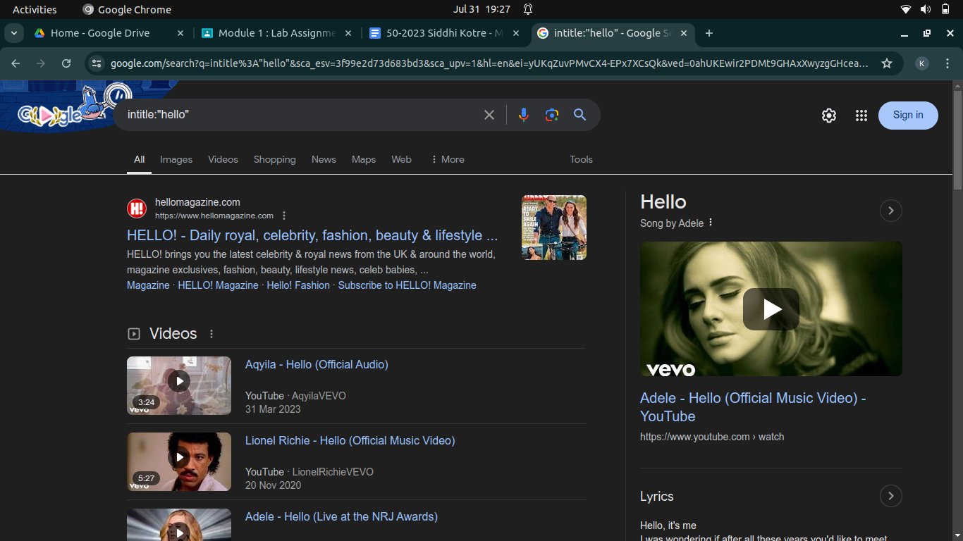

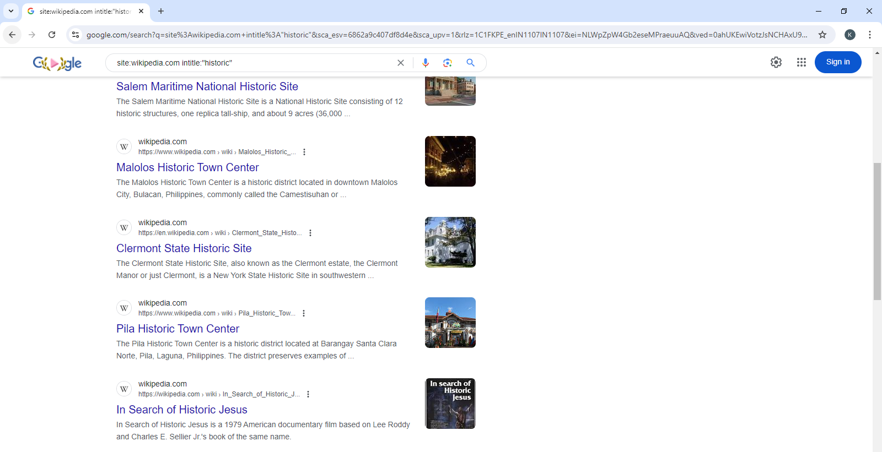

1. filetype:

search for specific document type

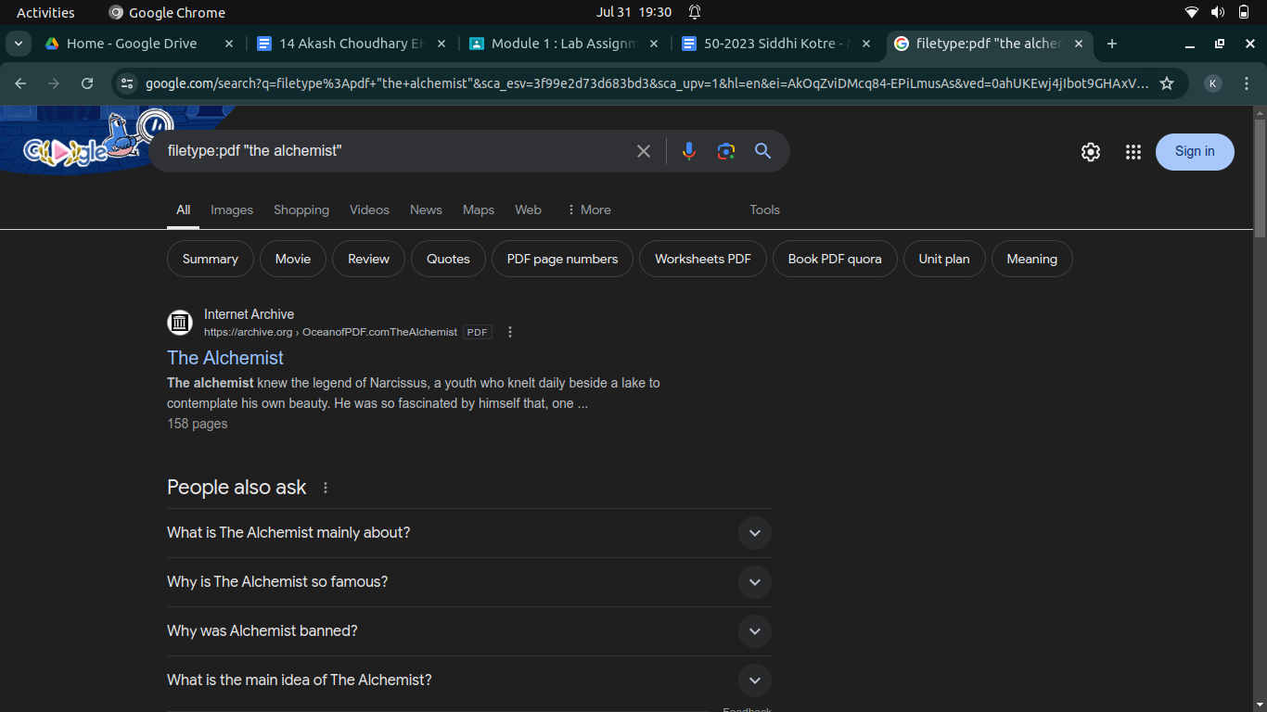

1. link:

search for pages with link

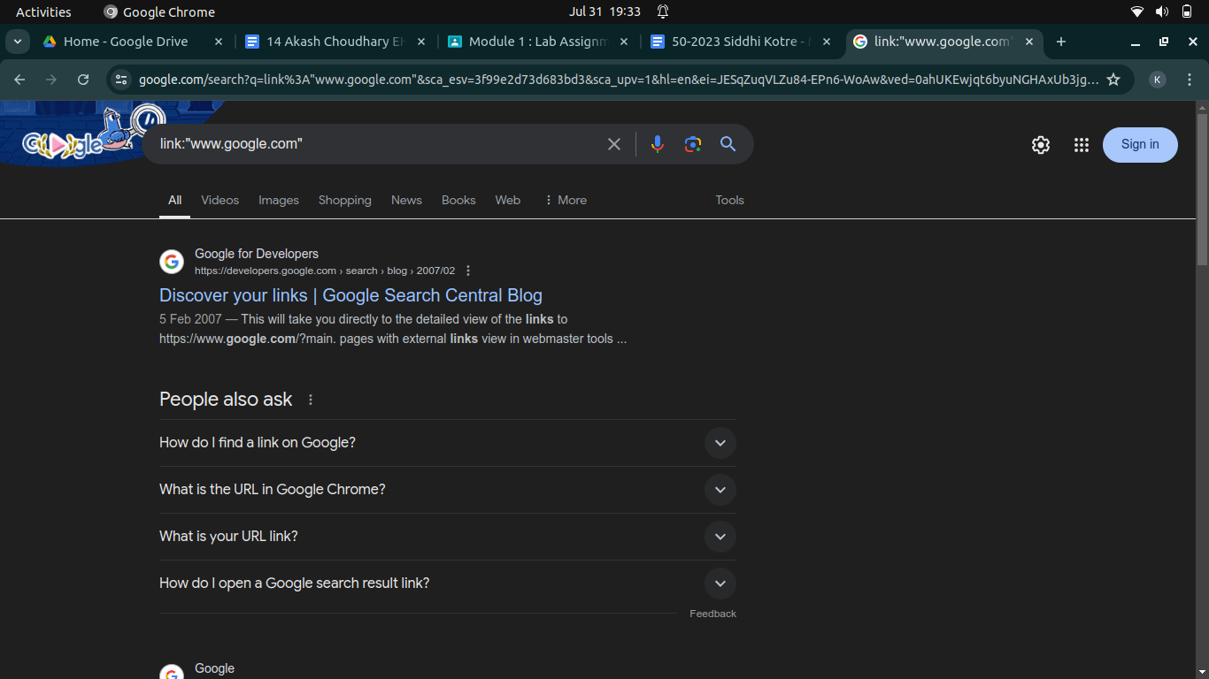

1. cache:

search cached version of a page

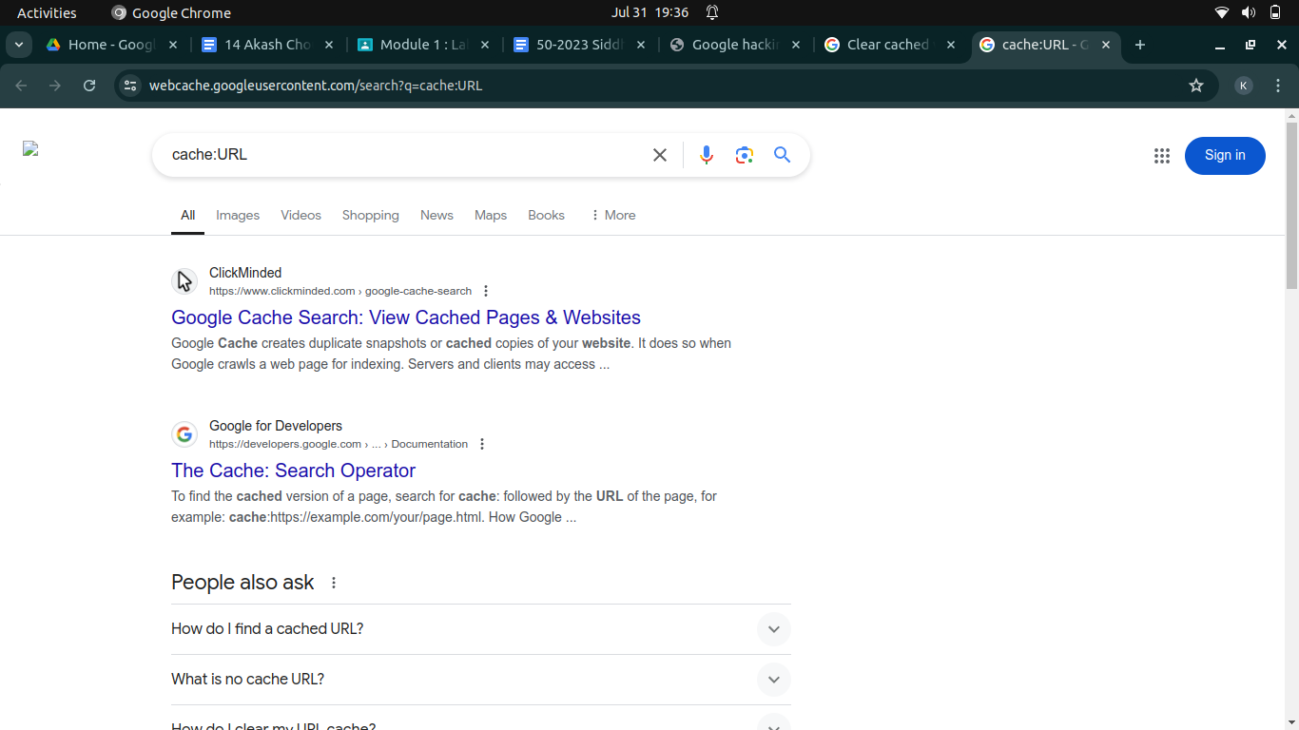

1. intitle:

search term in page title

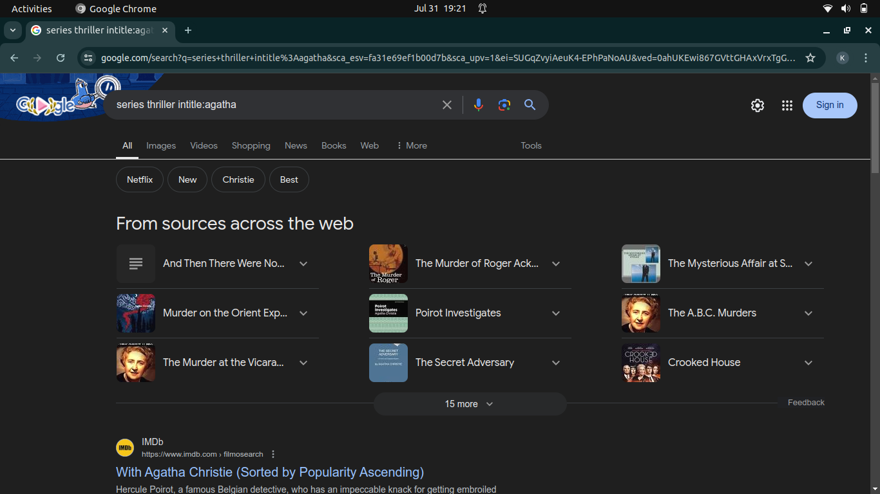

1. inurl:

search term in page URL

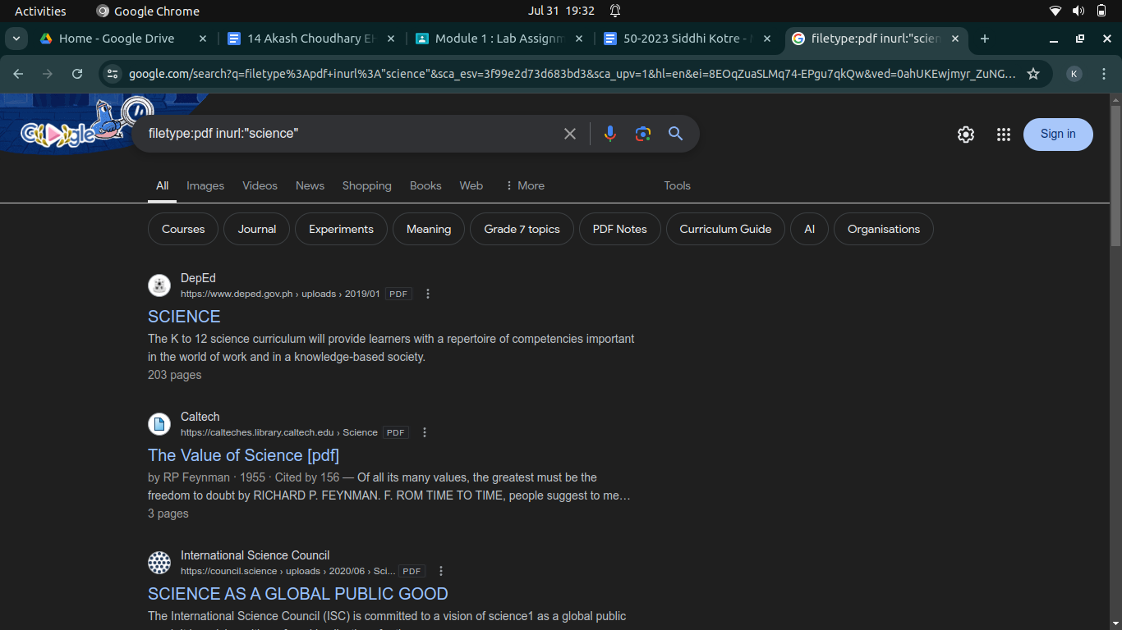

1. intext:

search term in page content - regular search

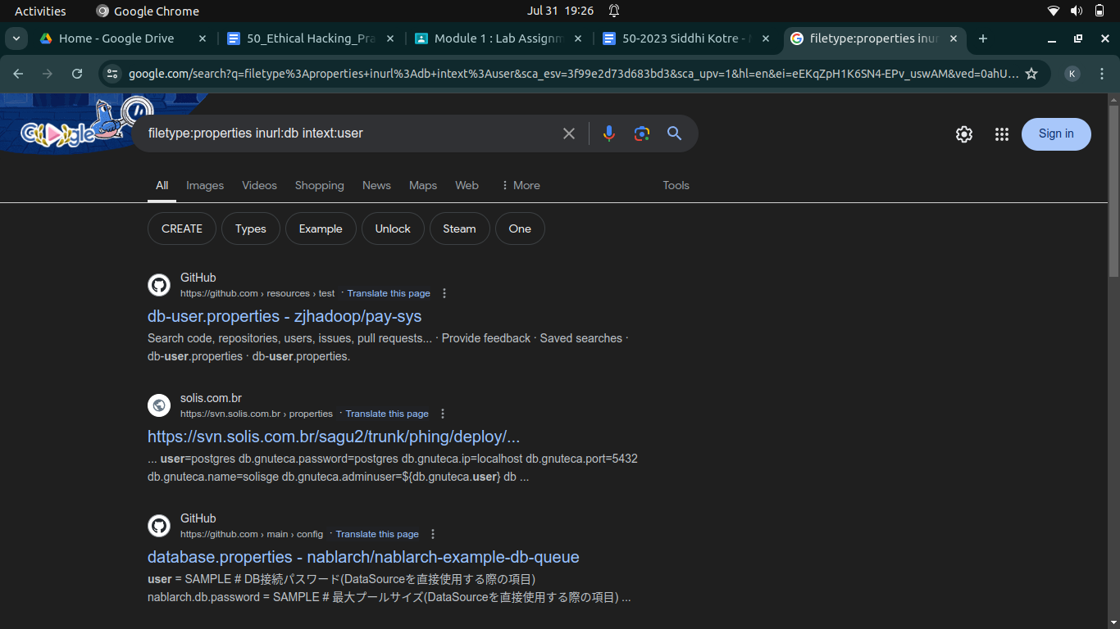

**References:**

<https://home.ubalt.edu/abento/753/footscan/googlehacking.html>

<http://pdf.textfiles.com/security/googlehackers.pdf>

**B.To find out information about website:**

<https://whois.domaintools.com/>

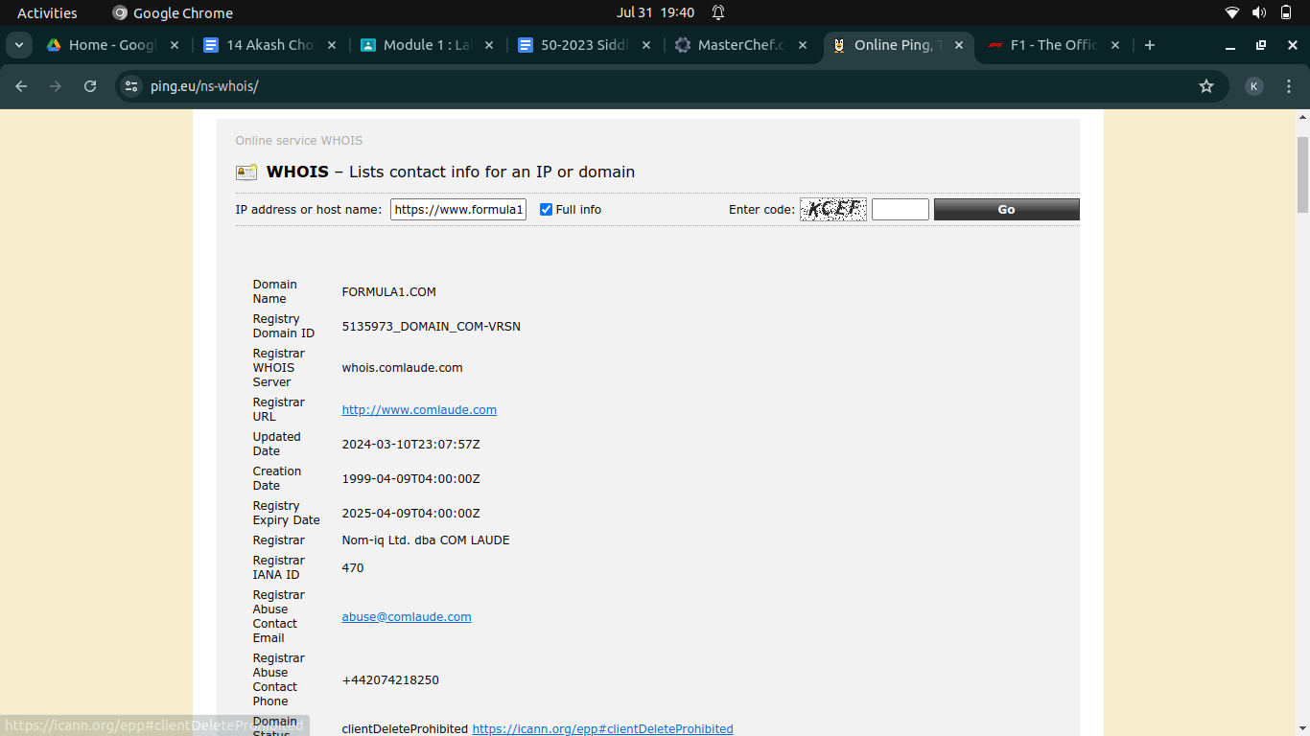

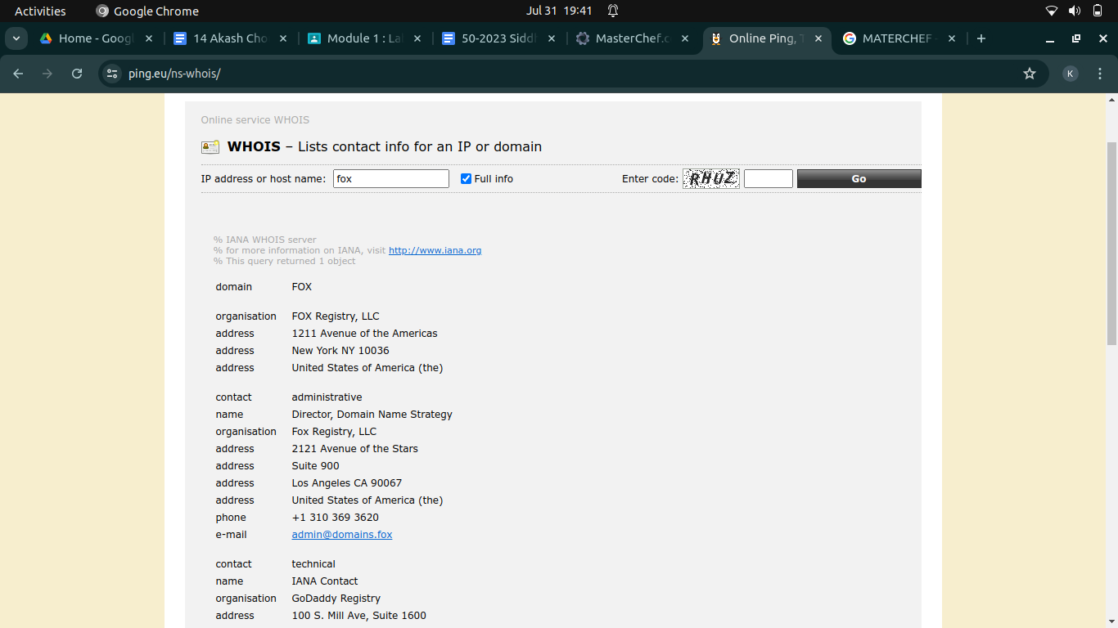

**C.To find information about archived website**

<https://archive.org/>

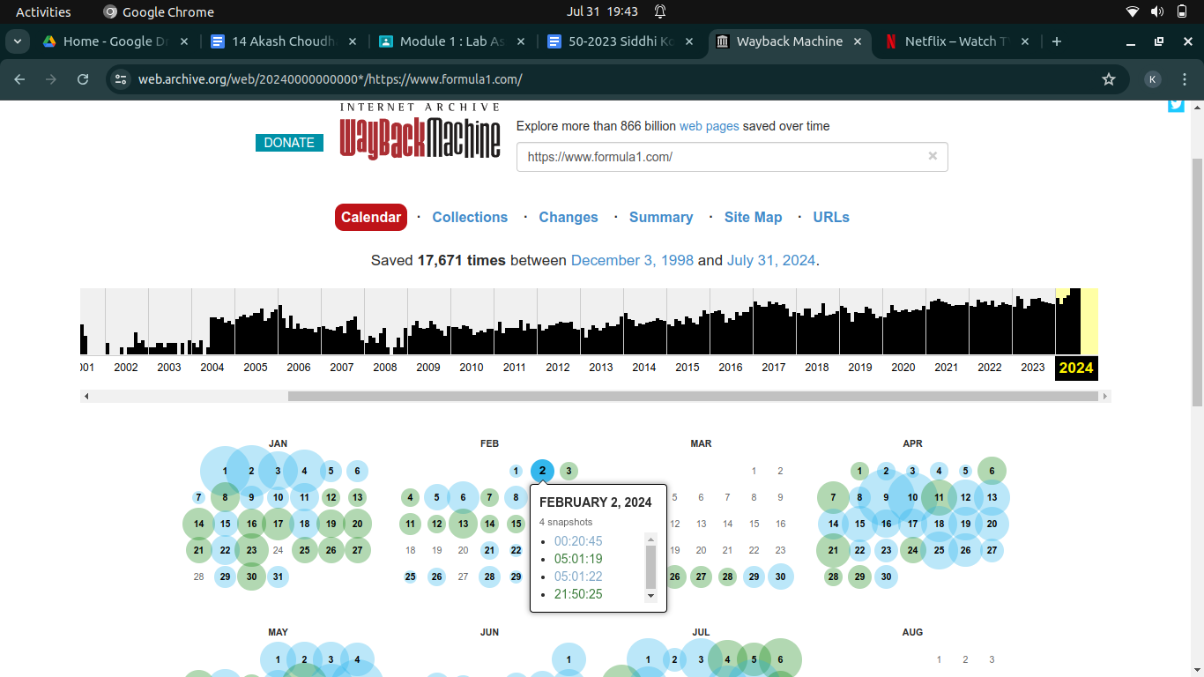

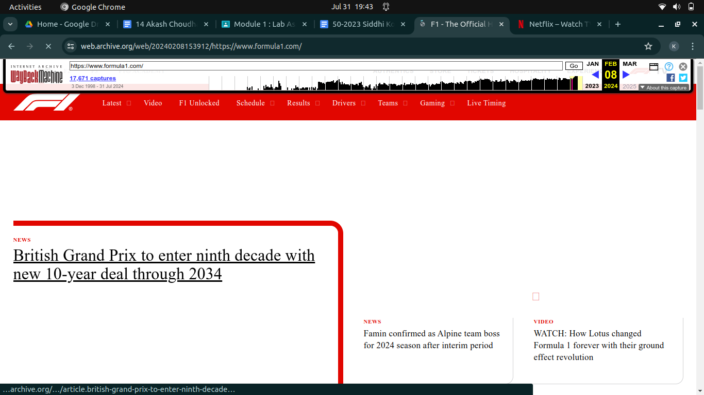

**D.To fetch DNS information.**

On cmd: nslookup url

OR

<https://ping.eu/>



